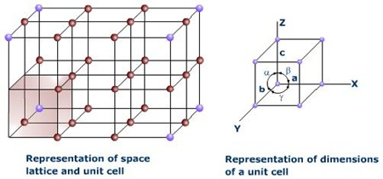***Lattice parameters:*** Arbitrary arrangements of crystallographic axes, marked *X*, *Y* and *Z*, defining a unit cell shown in the fig. The three sides of a unit cell which are called the *crystallographic axes.* The angles between the three axes $\left(α,β and γ\right)$ are called *interfacial angles*. The intercepts $a, b and c$ define the dimensions of a unit cell and are known *lattice parameters of the unit cell*. These are also called the *geometrical constants* of a given crystal.

***Unit Cell:*** A crystal lattice is made up of infinite repetitions of a small group of ions in three-dimensional pattern. It is built up by the combination of a regular array of ions in which each ion is surrounded by a definite number of ions of opposite charges.



The small group of ions which is repeated in a crystal lattice in three-dimensional pattern is known as a unit cell. The unit cell is thus the smallest portion of the crystal lattice which has all the various kind of symmetry which characterise the crystal.

*A parallelepiped shaped volume which reproduced by close packing in three dimension gives the whole crystal, is called the unit cell.* There are two types of unit cell:

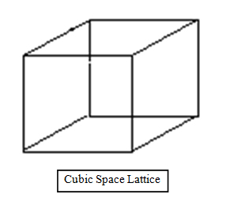

1. Primitive unit cell
2. Non-primitive unit cell

**Fig. 1.** Unit cell

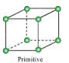***Primitive unit cell:*** The unit cell occupying the smallest volume in a given lattice is called the primitive unit cell. It contains only one lattice point.

***Non-Primitive unit cell:*** The unit cell which is larger than the minimum volume unit cell is defined as a non-primitive unit cell. A non-primitive unit cell contains more than one lattice point. The volume of a non-primitive unit cell is an integral multiple of a primitive cell.

***Distinguish between primitive unit cell & unit cell:***

|  |  |
| --- | --- |
| ***Primitive Cell*** | ***Unit Cell*** |
| 1. The unit cell occupying the smallest volume in a given lattice is called the primitive unit cell. | 1. A parallelepiped shaped volume, which reproduced by close packing in three dimensions gives the whole crystal is called the unit cell. |
| 2. It always contains only one lattice point. | 2. It may contain more than one lattice point. |
| 3. A primitive cell is the smallest cell in crystal. A cell smaller than it is never possible. | 3. A unit cell may be smallest or not. |
| 4. It is always a unit cell. | 4. But a unit cell is not always a primitive cell. |

***Lattice symbol ‘P’:*** The lattice symbol ‘P’ means the primitive cell where lattice points are at the corners of the cell. A primitive cell is always a unit cell.

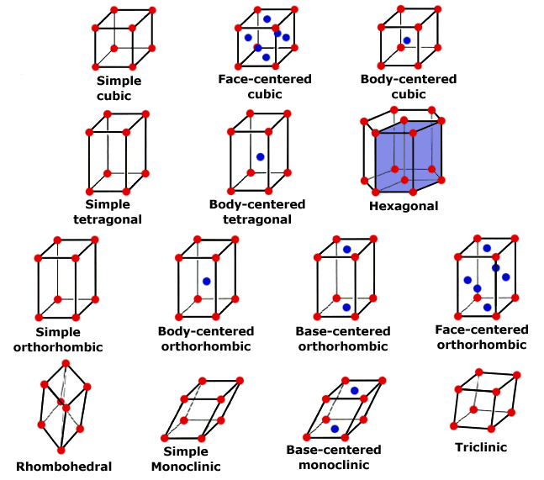

Simple cubic (sc)

***Lattice symbol ‘I’:*** The lattice symbol ‘I’ means the body centered lattice. In the body centered lattice, the lattice points are at the corners and inside the cell.

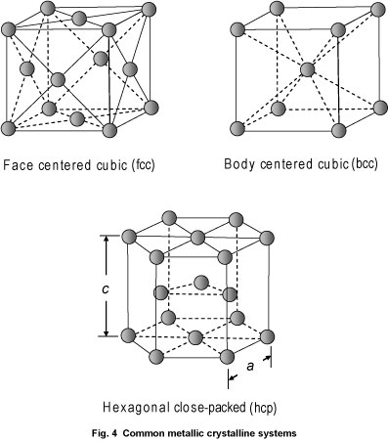

***Lattice symbol ‘F’:*** The lattice symbol ‘F’ means the face-centered lattice. In the face centered lattice, the lattice points are at the corners and all the faces centered.



***Lattice symbol ‘C’:*** The lattice symbol ‘C’ means the lattice is base centered or the side centered or C-face centered. In the base centered lattice, the lattice points are at the corners and at the face centered of opposite sides.

***Total Number of atoms in different unit cells***

The formula for the total number of atoms in a unit cell is

$$N=N_{i}+\frac{N_{f}}{2}+\frac{N_{c}}{8}$$

Where, $N_{i}=Points inside the cell$

$$N_{f}=Points on the faces$$

$$N_{c}=Points at the corners$$

***Primitive cell:*** For a primitive cell, the lattice points are at the eight corners of the cell. So for primitive cell $N_{i}=0, { N}_{f}=0 and N_{c}=8.$

Thus the total number of atoms in a primitive cell is

$$N=0+\frac{0}{2}+\frac{8}{8}=1$$

So, the primitive cell has only one lattice point.

***Body centered cubic:*** For a body centered cubic lattice, the lattice points are at the eight corners and inside the cell. So, for body centered cubic lattice $N_{i}=1, { N}_{f}=0 and N_{c}=8.$

Thus the total number of atoms in body centered cubic lattice is

$$N=1+\frac{0}{2}+\frac{8}{8}=2$$

So, the body centered cubic lattice has only two lattice points.

***Face-centered cubic:*** For a face centered cubic lattice, the lattice points are at the eight corners and all (six) the faces centered. So, for face centered cubic lattice $N_{i}=0, { N}_{f}=6 and N_{c}=8.$

Thus the total number of atoms in a face centered cubic lattice is

$$N=0+\frac{6}{2}+\frac{8}{8}=4$$

So, the face centered cubic lattice has only four lattice points.

***Base centered cubic:*** For a base centered cubic lattice, the lattice points are at the eight corners and two opposite faces centered. So for base centered cubic lattice ${ N}_{i}=0, { N}_{f}=2 and N_{c}=8.$

Thus the total number of atoms in a base centered cubic lattice is

$$N=0+\frac{2}{2}+\frac{8}{8}=2$$

So, the base centered cubic lattice has only two lattice points.

**[Include figure in each cases]**

***Seven crystal system***

The names of seven crystal system are: Triclinic, Monoclinic, Orthorhombic, Tetragonal, Cubic, Trigonal and Hexagonal.

***Restrictions on conventional cell axex and angles:***

|  |  |  |  |  |
| --- | --- | --- | --- | --- |
| **System** | **No. of lattice in the system** | **Lattice Symbol** | **Restrictions on** | |
| **Conventional cell axes** | **Conventional axial angles** |
| Triclinic | 1 | *P* | $$a≠b≠c$$ | $$α≠β≠γ$$ |
| Monoclinic | 2 | *P, C* | $$a≠b≠c$$ | $$α=γ=\frac{π}{2}≠β$$ |
| Orthorhombic | 4 | *P, C, I, F* | $$a≠b≠c$$ | $$α=β=γ=\frac{π}{2}$$ |
| Tetragonal | 2 | *P, I* | $$a=b≠c$$ | $$α=β=γ=\frac{π}{2}$$ |
| Cubic | 3 | *P, I, F* | $$a=b=c$$ | $$α=β=γ=\frac{π}{2}$$ |
| Trigonal | 1 | *R* | $$a=b=c$$ | $$α=β=γ<\frac{2π}{3}≠\frac{π}{2}$$ |
| Hexagonal | 1 | *P* | $$a=b≠c$$ | $$α=β=\frac{π}{2}, γ<\frac{2π}{3}$$ |

In practice seven crystal systems are possible. In real, lattices are grouped into seven crystal system according to certain specifications about the length of edges and angles between them of a conventional unit cell.

The seven crystal systems are: Triclinic, Monoclinic, Orthorhombic, Tetragonal, Cubic, Trigonal and Hexagonal.

***Triclinic:*** In the triclinic system, the single lattice type has a primitive unit cell (P) with three crystallographic axes of unequal lengths and unequal angles between them. *i.e.*

$$a≠b≠c$$

$$α≠β≠γ$$



***Monoclinic:*** In the monoclinic system, there are two lattice types: one with a primitive unit cell (P) and other with a non-primitive conventional cell which may be base centred with the lattice point at the centre of the rectangular cell faces. Where





$$a≠b≠c$$

$$α=γ=\frac{π}{2}≠β$$

***Orthorhombic:*** In the orthorhombic system, there are four lattice types: one lattice has a primitive unit cell (P), one lattice is base centered (C), one lattice is body centered (I), and one lattice is face centered (F). In this case



$$a≠b≠c$$

$$α=β=γ=\frac{π}{2}$$

***Tetragonal:*** In the tetragonal system, there are two lattice types: one is primitive unit cell (*P*) and another is body centered (*I*). In this case



$$a=b≠c \\ α=β=γ=\frac{π}{2}$$

***Cubic:*** In the cubic system, there are three lattice types: the simple-cubic lattice (sc), the body centered cubic (bcc), and the face centered cubic (bcc). In this case

$$a=b=c \\ α=β=γ=\frac{π}{2}$$



***Trigonal:*** In the Trigonal system, a rhombohedron is usually chosen as the primitive cell. In this case

$$a=b=c$$

$$α=β=γ<\frac{2π}{3}≠\frac{π}{2}$$



***Hexagonal:*** In the Hexagonal system, the lattice is primitive and for this

$$a=b≠c$$ $$α=β=\frac{π}{2}, γ<\frac{2π}{3}$$